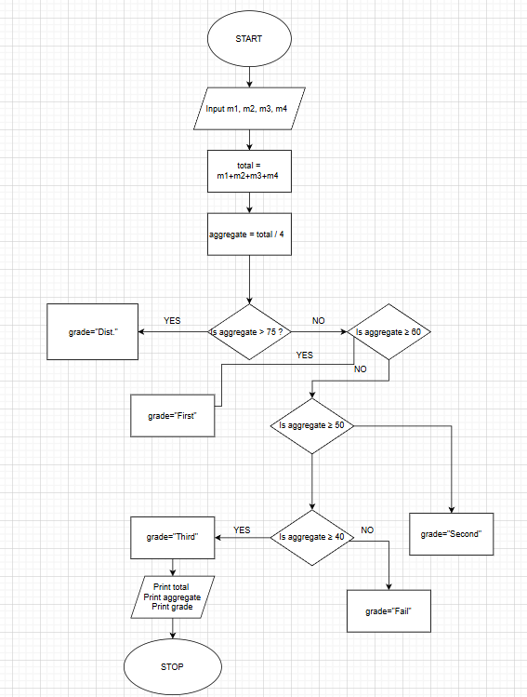
ALGORITHM
- Start
- Input marks of four subjects (m1, m2, m3, m4)
- Calculate total
$$total=m1+m2+m3+m4$$
- Calculate aggregate percentage
$$aggregate=total/4$$
- If aggregate > 75
→ grade = "Distinction"
- Else if aggregate ≥ 60
→ grade = "First Division"
- Else if aggregate ≥ 50
→ grade = "Second Division"
- Else if aggregate ≥ 40
→ grade = "Third Division"
- Else
→ grade = "Fail"
- Print total
- Print aggregate (two decimal places)
- Print grade
- Stop

5.1.2 Student Grade Based on Aggregate

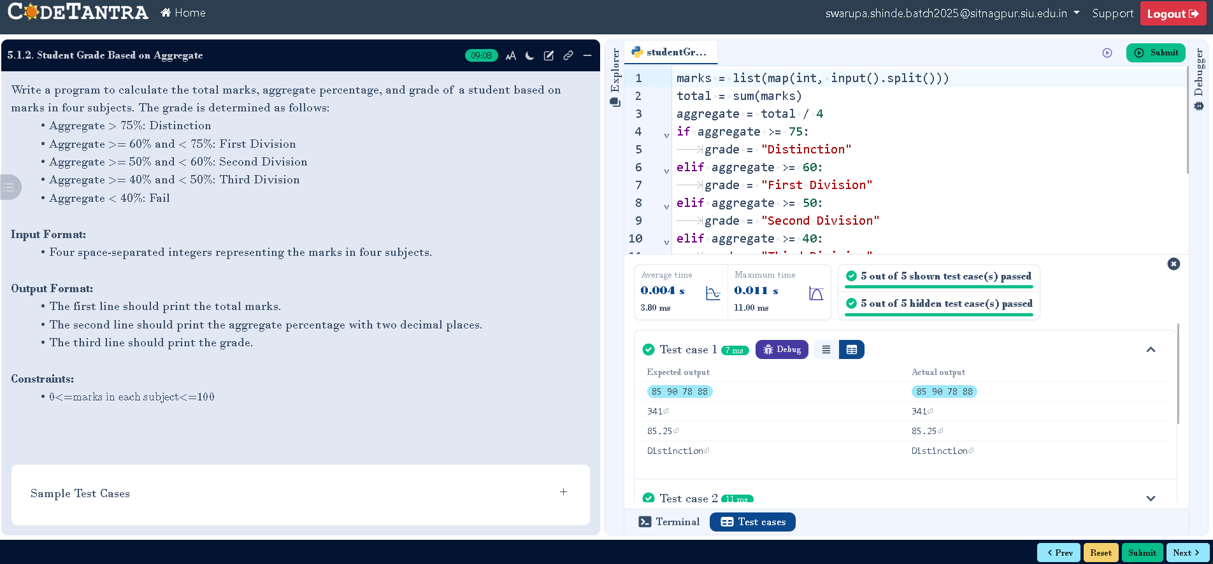
CODETANTRA:-

